The Application Process and the Programs at Give Hope, Inc.

Christina Wilson

Table of Contents
Introduction iii
Give Hope, Inc. iii
More Information on Hope, Inc. iii
History of the Organization iii
What You Can Do iii
Programs 3
30-90 Day Assistance 3
What it is 3
Qualifications 3
Staying on the Program 3
Assistance 3
Length of time on the Program 3
Emergency Housing Assistance 3
What it is 3
Qualifications 3
Assistance 3
Length of Time on the Program 3
Housing Counseling 3
What it is 3
Qualifications 3
Assistance 3
Transition Housing 3
What it is 3
Qualifications 3
Assistance 3
Your Duties 3
Length of Time on the Program 3
Applying for Assistance 3
What you will need for this process 3
Instructions 3
Troubleshooting 3
Problems with Submitting the Application 3
Any Other Problems 3
References 3
Definition of Homelessness 3
Index 3

Introduction

Give Hope, Inc.
Allison was having a hard time paying her rent. She had recently lost her job from her long time employment. She and her three children were about to be evicted onto the streets when she found Give Hope, Inc. After applying online in the hopes that she would be able to get monetary help from them, she received a phone call from a woman named Jane. Jane was her case manager. With her help, Allison was able to get in the 30-90 Day Assistance Program. With the money she received, she was able to pay her rent while still being able to feed her family. Now Allison has a job and is able to feed her children.
Figure 1: Tiz , Flickr

More Information on Hope, Inc.

A nonprofit organization that helps people who are homeless or at risk of becoming homeless with monetary assistance. In order to help, they apply for grants from the government and other sources. They have four different programs which provide assistance to those in need.

History of the Organization

Give Hope, Inc. was established in 1986 due to the national attention homelessness was receiving around the United States. Homelessness was increasing due to the mental institution closures. A group of concerned citizens and ministers did some research into the situation in the Denton County in Texas. They found that the fastest growing population of the homeless group was single females with children. So, they began Hope, Inc., which later became Give Hope, Inc. After three years of struggling as an organization, they were able to become a United Way agency.

What You Can Do

If you are in a financial crisis, you can use this manual to check and see if you meet the requirements for a certain program before you apply. This manual has information on all of their programs. If you need them, this manual will provide instructions on applying for assistance as well as troubleshooting issues.

Checklist

Do you fit in the programs?
Please go through this checklist to see if you have a chance for one of the programs.

Are you:
- Living in Denton County?
- A family with dependent children?
- Homeless?
- At risk of being homeless?
- Having a financial emergency?
- Looking for help with your budgeting and housing options?
- Unable to receive housing because of serious barriers such as not having a GED or eviction causing credit issues?

If you do have some of these issues, please look through the programs in the following section. Please apply to Hope, Inc. if you believe that Hope can help you.

Programs

Programs

This section will cover the four programs that Give Hope, Inc. offers and the qualifications for each program. They are:
- 30-90 Day assistance
- Emergency Housing Assistance
- Housing Counseling
- Transition Housing

30-90 Day Assistance
Figure 2: Images Money, Flickr
Robert had to have his gall bladder surgically removed because of the stones that were developing in it. The surgery went perfectly. Robert had a few days off his feet but he was back at work the following week. Unfortunately, the costs of his surgery were more than he could afford to pay both them and his rent. Unsure of how he could keep his home and pay both bills, he searched online for a solution. He found Give Hope, Inc. and applied hoping he would be able to receive monetary assistance. Give Hope accepted his application and helped him get back on track with his life.

What it is
30-90 day assistance is a grant that helps families financially for housing or other items as stated by the grant’s guidelines.

Qualifications
- Families with dependent children
- Individuals who are homeless or at risk of being homeless because of a documented emergency including:
  - Auto repair
  - Medical emergency
  - Job loss
- People who live in Denton County in Texas

Staying on the Program
Participants are required to:
- Want to become self-sufficient
  - Also known as being able to support themselves and their families
- Go to the appointments with their case managers
- Follow the program guidelines
  - For more information ask your case manager
- Do the activities set by the Program manager
  - The Program manager is the person who manages the various programs offered by Give Hope, Inc.

Assistance
If you qualify, you will receive monetary help for however long you are on the program. This is discussed in the section below.

Length of time on the Program
How long you are in 30-90 day assistance depends on a number of things. You qualify for the program based on:
- The program’s guidelines
- How well you follow the program’s guidelines
- How well you do the activities for the Program manager
You, and everyone in your household, qualify for financial assistance every twelve months. With a referral from the Director and the Program manager, you can be considered for financial assistance after a year.

Emergency Housing Assistance
Figure 3: nikcname Flickr
Joanna’s job had reduced her salary due to cut backs in the company she worked for. Unable to pay her bills, she searched around for options and found Give Hope, Inc. After applying, she received a call from Jerome, a case manager from Give Hope. With his help, she received the money she needed and planned a budget to keep up the payments on her bills.

What it is
It is a federal grant that gives monetary aid to people who have recently had an emergency causing their family to have trouble paying their rent.

Qualifications
You must be:
- A resident of the Northern Denton County area
- Having monetary difficulties because of an emergency including:
  - Fire
  - Medical emergency
  - Auto repair
  - Wage reduction
  - Temporary loss of a job
- Able to become financially stable after assistance is given.

Assistance
If you qualify, you will receive:
- Monetary help for one month.
- Help making a budget.
- Help planning financial actions for you to make the payments yourself.

Length of Time on the Program
This assistance is only for one month.

Housing Counseling
Figure 4: Tax Credits, Flickr
Luke was having trouble with his budget. It just did not make any sense to him. Confused, he looked around for some help online. A web search took him to Give Hope. Contacting them after seeing the Housing Counseling, he got a phone call from Helen. They had a meeting where they went over his problems with his budget and what he could do. Relieved, Luke planned a budget with her help. Give Hope helped him with his monetary problems by helping with his preparation for the future.

What it is
This program is financial education and planning by having people go through their financial issues to look for options; one of these problems is housing options.

Qualifications
Anyone who wants to have financial education can request it. You do not have to be in a program or receiving assistance to do this. If you are in a program, it is required for you to receive housing counseling.

Assistance
You will receive help planning a budget and creating a long term financial plan.

Transition Housing

Daphne and her two children, Melissa and Jake, were homeless after running from an abusive relationship. Without a work history, Daphne and her children stay in a shelter. Daphne did not want this to be the future home for her children. Desperate, she asked around for options and heard of Give Hope, Inc. Going to her local library, she applied online hoping Give Hope would be able to do something. She received a visit from Diane, her newly appointed case manager. She was put into an apartment with her children and managed to get a job. Over the next year, Daphne worked towards the goals she set for herself and followed the program guidelines. A year later, she is in a stable job and an apartment she is paying for herself. With Give Hope’s help she was able to become self-sufficient and can now take care of herself and her children.
Figure 5: GJ Charlet III, Flickr

What it is
This program helps families by paying for their rent and utilities in program apartments for a year, possibly two depending on their progress. Note: This program is only available if funding is available.

Qualifications
You must be:
- Homeless as defined by the HUD (in a shelter or verified on the streets)
  - More information on this can be found in the reference section
- Parent(s) with minor children
- Able and willing to work
- Motivated to become self-sufficient
- Unable to receive stable housing due to serious obstacles including:
  - Need GED or job skills
  - Poor or no work history
  - Eviction or other credit problems barring you from being eligible for an apartment
  - Temporary health issues
- Able to overcome these barriers in more than a few month
  - Time limit is 1 to 2 years

Assistance
You will receive:
- Monetary assistance for 1 year
  - There is a possibility of a 2nd year depending on your progress
- Intensive case management
- Skills development for
  - Basic financial needs
  - Decision making
- Help in setting goals
- Help implementing the goals you set

Your Duties
While on this program you must:
- Pay deposits
- Pay 30% of the adjusted total income as the client portion of the rent and utility assistance to help cover program costs
- Make progress towards the goals you set

Length of Time on the Program
This program is for however long you need the assistance for up to 1 year. There is a possibility of you receiving aid for a 2nd year if you have made good progress for your goals. Please note that this is only possible if funding is available.

Applying for Assistance

Applying for Assistance

What you will need for this process
- A computer
- Your contact information
- Your permanent address
- Your rent bill
- Your utilities bill

Instructions

- Get onto your computer.
- Open any browser
- Type in: http://www.hopeincdenton.com/
  - The following page should come up:

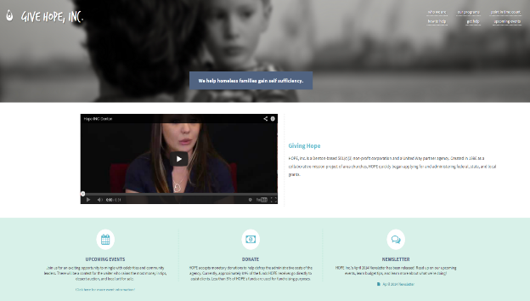

- Click on the “get help” link located in the top right hand of the page.
  - This is indicated by the orange arrow.

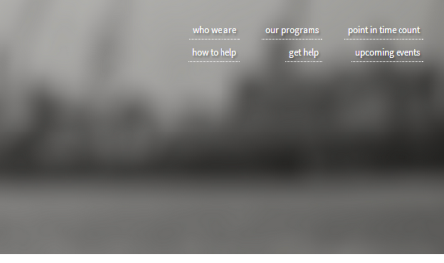

- The following page should come up:
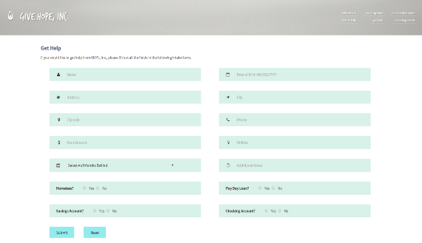

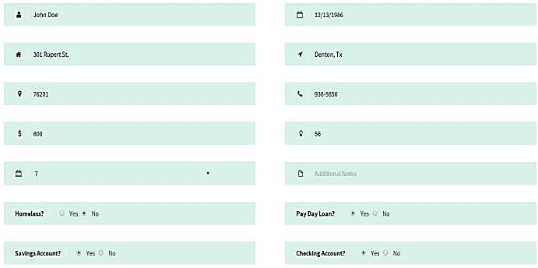
- Fill in the application with the information in the correct boxes.
- Once you have filled out the form click on the “submit” button on the bottom of the screen.
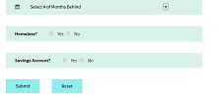
  - The button is indicated by the orange arrow.
- Once you have submitted the form, you should get the following check mark:
- Congratulations! You have completed the application for Hope, Inc.!
Troubleshooting

Troubleshooting

Problems with Submitting the Application

If you have a problem with the information on the application, please remember that you can reset the form by clicking on the reset button as indicated with the orange arrow.

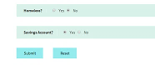

If you receive a screen with this:
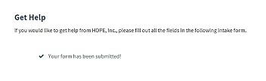
Then you have not filled out all of the boxes with information. However, if you do not have the information then do not worry about it. The form will be submitted either way.

Any Other Problems
If you have any other problems, Please contact Give Hope, Inc. by phone: (940) 382-0609 or on their website in the “Contact us” section.

References

References

Definition of Homelessness
Provided by the U.S. Department of Housing and Urban Development
- Individual or family who lacks a fixed, regular, and adequate nighttime residence, meaning:
  - Has a primary nighttime residence that is a public or private place not meant for human habitation;
  - Is living in a publicly or privately operated shelter designated to provide temporary living arrangements (including congregate shelters, transitional housing, and hotels and motels paid for by charitable organizations or by federal, state and local government programs); or
  - Is exiting an institution where (s)he has resided for 90 days or less and who resided in an emergency shelter or place not meant for human habitation immediately before entering that institution

For further information please go to:
- Give Hope, Inc. at: http://www.hopeincdenton.com/
- U.S. Department of Housing and Urban Development at: http://portal.hud.gov/hudportal/HUD?src=/program_offices/comm_planning/homeless

Index

30-90 Day Assistance, 7
Applying for Assistance, 13
Assistance, 11
Emergency Housing Assistance, 8
History, v
Homelessness, 23
Housing Counseling, 9
Problem, 19
Qualifications, 10
Transition Housing, 10
Troubleshooting, 19

